Phylogenetics project
  - Close relatives of the Arctic fox (Vulpes lagopus) among canines

Introduction
The research question is “what other member of the family Canidae is closest related to the Arctic fox (Vulpes lagopus)?” and therefore I have tried to select a few other Vulpes and a spread of other Canidae (Table 1). The outgroup is the Red panda (Ailurus fulgens) as both Ailuridae and Canidae families belong to the suborder Caniformia.
My expectation is that one of the Vulpes species will be closest related to the Artic fox while the rest of the species are further removed. Other morphologically fox-like species can be expected to be closer than the wolf-like ones. Out of the Vulpes species, I expect the red fox (Vulpes vulpes) to be the closest relative to the arctic fox as they share neighbouring habitats (i.e. live relatively close geographically) as well as many morphological traits.
For each species, a complete mitochondrial genome and the Cytochrome B gene were retrieved from RefSeq or GenBank, depending on availability.
Table 1: Species included in study.
 | Latin name | Common name | RefSeq/GenBank ID
Ingroup (Caniformia -> Canidae)
 | Vulpes lagopus | Arctic fox | OR880609.1
 | Vulpes vulpes | Red fox | NC_008434.1
 | Vulpes ferrilata | Tibetan sand fox | NC_027935.1
 | Vulpes macrotis | Kit fox | PV090784.1
 | Urocyon cinereoargenteus | Gray fox | MW600068.1
 | Otocyon megalotis | Bat-eared fox | MW257223.1
 | Nyctereutes procyonoides | Common raccoon dog | NC_013700.1
 | Lycaon pictus | African hunting dog | NC_028427.1
 | Chrysocyon brachyurus | Maned wolf | NC_024172.1
 | Cuon alpinus | Dhole | NC_013445.1
 | Canis lupus lupus | Eurasian wolf | NC_009686.1
 | Canis aureus | Golden jackal | NC_067757.1
Outgroup (Caniformia -> Ailuridae)
 | Ailurus fulgens | Red panda | NC_011124.1

Result
Sequences were aligned with MAFFT using the FFT-NS-1 (fast) algorithm. Tree reconstruction was then performed with IQ-TREE in MFP mode. Best-fit model according to Bayesian information criterion (BIC) was TIM2+F+I+G4 for the full mitochondrion and TPM2+F+I+G4 for Cytochrome B. Difference between these models lie in base substitution rates where TPM2 assumes the substitution rate for AC=AT, AG=CT, CG=GT are equal and remaining possible substitutions have equal base frequency. TIM2 assumes only AC=GT, AT=CG have equal frequency and remaining substitutions have unequal base frequency.
The reconstructed trees grouped roughly as expected, with species grouping within their respective Genus. In trees reconstructed with both full mitochondrial and Cytochrome B the closest relative to the Arctic fox was the Kit fox (Figure 1, teal highlight). Based on the full mitochondrial genome (Figure 1A) the closest related Genus to Vulpes was Nyctereutes containing the Common raccoon dog. The more wolf-like species were placed as a separate group equally related to all other fox-like species. For the tree based on Cytochrome B (Figure 1B), however, Vulpes was placed as equally related to all other Canidae, including wolf- and fox-like species. I find the full mitochondrial genome based tree more likely to give a true representation of the species relationship.

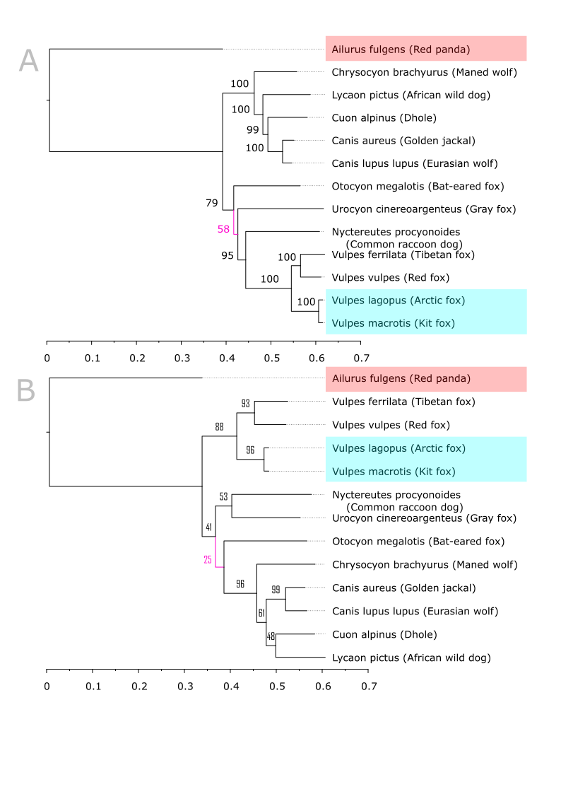
Figure 1: Phylogenetic trees reconstructed with IQ-TREE and sorted in decreasing order for complete mitochondrial genome (A) and Cytochrome B (B). Outgroup, Ailurus fulgens (Red panda), highlighted in red. Target species, Vulpes lagopus (Arctic fox), and closes relative, Vulpes macrotis (Kit fox), highlighted in teal. Least supported branch by bootstrap (1 000 iterations) in pink.

